School “Vzmakh”
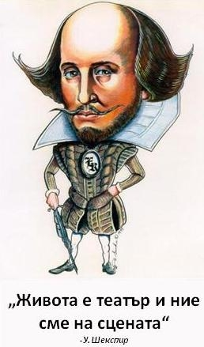

Research by Daniel Drogobuzhskiy
English supervisor: Aleksandr Kondratov, Muranova Tatiana
Russian supervisor: Julia Oseeva
2011
Saint Petersburg

Contents

Introduction 3
Chapter 1. England in Shakespearean times 4
Chapter 2. Biography of Shakespeare 5
Chapter 3. The versions about authorship 7
Conclusion 13
Appendix 14

Introduction

I would like to present you the topic of my work, explain why it is actual and deserves research. In this research I will try to solve the problem about Shakespeare's identity and often talk about everything which is connected with the time Shakespeare lived in.
I’ve chosen this topic because I read some books which were written by this greatest author. His works cover a variety of age: from antiquity to his time, different countries, customs and traditions of people of different nationalities, beliefs and social classes. Like other people, I was interested in his biography and literature. Question arose when I studied his plays - how should have been well educated and knowledgeable man to wrote these brilliant lines!
And what was my surprise when I read in his biography that neither genealogy, neither education Shakespeare could boast.
Intrigued by this coincidence, I began to seek an explanation of them in various literary and scientific sources, and discovered a huge number of questions, that did not found unequivocal answers until our time.
In my academic writing I have touched only a few of the most interesting and popular versions of the authorship of the well-known works.
My scientific research will consist of 4 parts: introduction, then in the first chapter I will tell you about the time Shakespeare lived in. In the second chapter I will talk about the biography of William Shakespeare and who he was. In the third chapter I will talk about the problem of identity of William Shakespeare and at the last I will tell my opinion and what I understand from this academic writing.

Chapter 1. England in Shakespearean times

England of Shakespeare's time was predominantly rural, and virtually untouched by human hand. The population of the entire country was probably around 3 million, compared to nearly 60 million today.
The economy was still mainly agricultural, with workers tied to the land. Wool was the most precious, but mundane, commodity. Trade in exotic imports from the Americas, the Caribbean, India and China was on the increase.
It was also time of fear and upheaval, with society divided and population governed by a brutal and paranoid State.
Shakespeare lived most of his life during the Elizabethan Age. During Shakespeare's life, England had three big epidemics of the plague. This is when lots of people got very sick and died. The plague was like a flu which was very easy to catch. The first plague went around from 1592-1594. This was when Shakespeare was about 30 years old and when he wrote poems and performed plays. The second plague happened when Shakespeare was old, going from 1603 to 1604. The final plague was 7 years after Shakespeare died. The plague in England was really bad because English cities had narrow, dirty streets and no clean water. They also had lots of rubbish and rats on the road.
In Elizabethan times, London was a very rich city. It traded with many countries. In the countryside there were many farmers who had cattle, sheep and chickens. They also grew vegetables, fruit, wheat, oats and barley.
During Elizabethan times there was lots of entertainment. Many people went to Inns and Taverns when others went to watch rooster-fighting, beer baiting and watched beatings and executions. People also had bets and played cards, chess pieces and dice. A popular sport game was tennis, but people didn't have racquets so they had to use their hands to hit the ball. Other sports were bowls, badminton, archery, billiards, hunting, riding and wrestling. Another form of entertainment important for Shakespeare was going to the theatre and watching people perform a play. Apart from these, there were other things you could do too.
In Shakespeare's time, England had three types of money. There were pence, shillings and pounds. 12 pence made a shilling and 20 shillings made a pound. Items in England could be bought for a very cheap price. For example 7 shillings would buy you gloves and one or two pence would get you a drink.
In Elizabethan England, most people believed in ghosts, witches and magicians although their religion was Christian. All English belonged to the Church of England. Shakespeare showed that people believed in things like witches in his plays like Macbeth. There were also ghosts in “Hamlet” and “Julius Caesar” and fairies in A “Midsummer Night's Dream”.
There were enough jobs to choose from for the people who lived in Elizabethan England. There were booksellers, people who made clothes and hats, people who made bows, arrows and armor, some worked in shops, there were people who gave you legal service and medicine. There were heaps of other jobs which we don't have now.

Chapter 2. Biography of Shakespeare
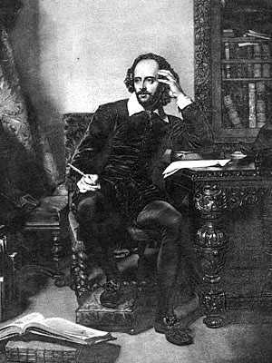
Details about William Shakespeare’s life are sketchy, mostly mere surmise based upon court or other clerical records. His parents, John and Mary (Arden), were married about 1557; she was of the landed gentry, he a yeoman—a glover and commodities merchant. By 1568, John had risen through the ranks of town government and held the position of high bailiff, similar to mayor. William, the eldest son, was born in 1564, probably on April 23, several days before his baptism on April 26, 1564. The fact is that Shakespeare also died on April 23, 52 years later, may have resulted in the adoption of this birthdate.
William attended the local grammar school in Stratford where his parents lived, and would have studied primarily Latin rhetoric, logic, and literature. At the age of 18 (1582), William married Anne Hathaway, a local farmer’s daughter eight years his senior. Their first daughter (Susanna) was born six months later (1583), and twins Judith and Hamnet were born in 1585.
Shakespeare’s life can be divided into three periods: the first 20 years in Stratford, which include his schooling, early marriage, and fatherhood; the next 25 years as an actor and playwright in London; and the last five in retirement back in Stratford where he enjoyed moderate wealth gained from his theatrical successes. The years linking the first two periods are marked by lack of information about Shakespeare, and are often referred to as the “dark years”; the transition from active work into retirement was gradual and cannot be precisely dated.
John Shakespeare had suffered financial reverses from William’s teen years until well into the height of the playwright’s popularity and success. In 1596, John Shakespeare was granted a coat of arms, almost certainly purchased by William, who the next year bought a sizable house in Stratford. By the time of his death, William had substantial properties, both professional and personal, which he bestowed on his theatrical associates and his family (primarily his daughter Susanna, having rewritten his will one month before his death to protect his assets from Judith’s new husband, Thomas Quiney, who ran afoul of church doctrine and public esteem before and after the marriage).
Shakespeare probably left school at 15, which was the norm, and took some sort of job, especially since this was the period of his father’s financial difficulty. Numerous references in his plays suggest that William may have in fact worked for his father, thereby gaining specialized knowledge.
At some point during the “dark years,” Shakespeare began his career with a London theatrical company—perhaps in 1589—for he was already an actor and playwright of some note in 1592. Shakespeare apparently wrote and acted for Pembroke’s Men, as well as numerous others, in particular Strange’s Men, which later became the Chamberlain’s Men, with whom he remained for the rest of his career.
When, in 1592, the Plague closed the theaters for about two years, Shakespeare turned to writing book-length narrative poetry. Most notable were “Venus and Adonis” and “The Rape of Lucrece,” both of which were dedicated to the Earl of Southampton, whom scholars accept as Shakespeare’s friend and benefactor despite a lack of documentation. During this same period, Shakespeare was writing his sonnets, which are more likely signs of the time’s fashion rather than actual love poems detailing any particular relationship. He returned to play writing when theaters reopened in 1594, and published no more poetry. His sonnets were published without his consent in 1609, shortly before his retirement.
Amid all of his success, Shakespeare suffered the loss of his only son, Hamnet, who died in 1596 at the age of 11. But Shakespeare’s career continued unabated, and in London in 1599, he became one of the partners in the new Globe Theater, built by the Chamberlain’s Men. This group was a remarkable assemblage of “excellent actors who were also business partners and close personal friends . . . including Richard Burbage . . . who all worked together as equals . . .”.
When Queen Elizabeth died in 1603 and was succeeded by her cousin King James of Scotland, the Chamberlain’s Men was renamed the King’s Men, and Shakespeare’s productivity and popularity continued uninterrupted. He invested in London real estate and, one year away from retirement, purchased a second theater, the Blackfriars Gatehouse, in partnership with his fellow actors. His final play was Henry VIII, two years before his death in 1616.
Incredibly, most of Shakespeare’s plays had never been published in anything except pamphlet form, and were simply extant as acting scripts stored at the Globe. Only the efforts of two of Shakespeare’s company, John Heminges and Henry Condell, preserved his 36 plays (minus Pericles, the thirty-seventh) in the First Folio. Heminges and Condell published the plays, they said, “only to keep the memory of so worthy a friend and fellow alive as was our Shakespeare”. Theater scripts were not regarded as literary works of art, but only the basis for the performance. Plays were a popular form of entertainment for all layers of society in Shakespeare’s time, which perhaps explains why Hamlet feels compelled to instruct the traveling Players on the fine points of acting, urging them not “to split the ears of the groundlings,” nor “speak no more than is set down for them.”
Present copies of Shakespeare’s plays have, in some cases, been reconstructed in part from scripts written down by various members of an acting company who performed particular roles. Shakespeare’s plays, like those of many of the actors who also were playwrights, belonged to the acting company. The performance, rather than the script, was what concerned the author, for that was how his play would become popular—and how the company, in which many actors were shareholders, would make money.
William Shakespeare died on April 23, 1616, and was buried two days later in the chancel of Holy Trinity Church [appendix 3] where he had been baptized exactly 52 years earlier. [appendix 1.]

Chapter 3. The versions about authorship

The historical records concerning William Shakespeare’s life reveal many strange paradoxes. While the records from the theatrical world in London show that he worked as an actor and playwright, the contemporary documentation from Stratford-upon-Avon reveals no theatrical or literary interests of any kind. No record exists of Shakespeare receiving an education, buying a single book or writing poems or plays. Over the years this enigma has led to speculation that Shakespeare was not the author of the plays attributed to him. Various candidates have been proposed as the “real” author.
There are many versions about who Shakespeare was. For example some people say that there were 2 men, bearing the same name which had the same surnames: Shakespeare but one of them lived in Stratford, and another in London. The man who lived in London wrote all the plays but the man who lived in Stratford didn’t write anything. The other theory says that it was one man who called himself Shakespeare but his true name was Christopher Marlo. Somebody says that it was Edward de Verne or count Ratlend. Some people say that it was Francis Bacon or earl of Oxford. Some versions are even impossible like the version that Shakespeare was illegitimate son of the Queen Elizabeth the first. One is clear: the soulful plays of William Shakespeare do not mix with his business acumen.
The fact remains: the "plain wild stone" encloses the grave of the poet in poetic form written in Old English:
"Good friend, in Jesus' name
Do not remove the dust, was buried here.
Let it be blessed who will not touch these stones,
And let him be cursed who disturb my bones. "
Some literariness assert, that Shakespeare (or person, who called himself like that) was wary frightened of the opening of the tomb so he wrote this small poem.
The other version is that something lies in the tomb of William Shakespeare (or person, who called himself like that) and he didn’t want if someone will open this tomb.
There are many other legends about William Shakespeare; I have listed only the most important.
Francis Bacon

One of the first "woman, that thing that there wasn’t any Shakespeare" was an American writer Delia Bacon [appendix 5]. In 1857 she published the book "Revealed philosophy of Shakespeare's plays, where claims that the author of Shakespeare's plays were a group of freethinkers, united by the same political views, headed by the philosopher Francis Bacon [appendix 4]. To convey their ideas to the public, the authors present them in accessible theatrical genres and for security reasons subscribed name a little-known actor. Obsessed with the idea, Delia Bacon spent hours at the tomb in Stratford, and once tried to move the tombstone, hoping to find a cache of documents, unlocking the secrets of Shakespeare. Shortly thereafter, she fell ill and lost her mind in what many saw the curse. Whatever it was, Delia Bacon was unable to prove the theory about the authorship of Francis Bacon.

Christopher Marlowe

Contender for the authorship - the poet and playwright Christopher Marlowe [appendix 2]. The same age as Shakespeare, he also went with him to London's theatrical world. They had the same ideas, thoughts… However Marlowe received an excellent college education. Spinning in a circle, playwrights mutually influenced each other. Like Shakespeare, Marlowe saw the origins of the tragedy are not in external circumstances, and in severe internal contradictions of the characters. In 29 years, Marlowe was killed by one of the versions, in a drunken brawl. Adherents reject the fact of authorship of Marlowe's early death, and link to secret espionage activities for the playwright royalty. Marlowe's death was staged for the benefit of the Crown, are convinced scientists, that Shakespeare was Marlowe. "Died", the playwright appeared in London in the form of a provincial actor under the name "William Shakespeare" and wrote the best works of Shakespeare. According to the theory of Hoffman, Marlowe dramatized his own murder in a tavern south of London, but the real victim was foreign seamen. Having escaped to the continent, Marlow continued to write plays that have brought him recognition in London, and send them to England for performances under the name of Shakespeare.

Earl of Oxford

In the early twentieth century, the English professor and literary scholar Thomas Looney conjectured that the name "Shakespeare in his works signed poet-nobleman Edward de Vere, Earl of Oxford [appendix 7]. His works surprisingly came in style to Shakespeare's poem "Venus and Adonis." In favor of his theory Looney gave several arguments. Earl of Oxford was well acquainted with opaque court intrigues, wherewith abound in the works of Shakespeare. Oxford Coat of Arms crowned lion, a stunning spear. Finally, Earl of Oxford was known as the patron of theatrical troupes. Having studied the works of Shakespeare, Thomas Looney was a psychological portrait of the true author. Among its features - an eccentric, deep erudition, belonging to the higher circles of society, knowledge of Italy, the lack of mercantile interests, love of music, familiarity with the aristocratic entertainment. All stated as the ideal match Earl of Oxford, but not William Shakespeare. In Anglophone version of the Looney very popular. The theory that says that there was real Shakespeare holds, and Sigmund Freud.

Lord Ratlend
Roger Manners, 5th Earl of Rutland (6 October 1576 – 26 June 1612) was the son of John Manners, 4th Earl of Rutland. He married Elizabeth Sidney (daughter of Sir Philip Sidney and stepdaughter of Robert Devereux, 2nd Earl of Essex), on 5 March 1599. He died in 1612, aged 35 and his titles passed to his brother, Francis Manners. He was a student at Oxford and Cambridge, Gray's Inn, and University of Padua, Italy. He travelled across Europe, took part in military campaigns led by Essex, and was a participant of Essex's rebellion against Queen Elizabeth I. He was favoured by James I, and honoured by his contemporaries as a man of great intelligence and talent. He enjoyed the friendship of some of the most prominent writers and artists of the Elizabethan-Jacobean age. In 1602 he led an Embassy to Denmark, homeland of James' Queen Anne of Denmark.
Evidence indicates that the Earl was a patron of Inigo Jones and probably introduced Jones to the Court of James I and Anne of Denmark, where Jones had his impact as both an architect and a designer of Court masques.
He can be the true candidate, because Ratlend studied at the University of Padua, together with Rosencrantz and Guildenstern (actors in "Hamlet ").

The version about 2 men

The works of Shakespeare are extremely multifaceted. At the time, doubts were expressed that they might withdraw from the pen of one man - particularly a poorly educated, as far from a brilliant actor from Stratford. Exalted play with their intricate plots and memorable characters, amazing depth and breadth of human emotions and reflect the author's knowledge of history, literature, philosophy, law, and even court etiquette. From this hick who belonged to the lowest levels of society, knew how to behave aristocrats and lawyers say? Perhaps the actor allowed to use their name educated man, holds a high position and who wanted to keep secret his authorship? In 1781, English clergyman John Wilmot, studying the archives of Stratford, came to the conclusion: a man of such descent, as Shakespeare did not have the education and experience to create these immortal works. Not wanting to publish his work, Wilmot had burned all the records.

The main argument of scientists that
there wasn’t any Shakespeare

Thus, the main argument of the scientists, that there wasn’t any Shakespeare is the contradiction between the historical figure of William Shakespeare and his works. The few facts relied upon by advocates of both theories admit the contradictory and ambiguous interpretations. Be that as it may, the works, known to us as Shakespeare, are the fruit of the greatest genius, an outstanding humanist and scholar of human nature. Attribution theory, on the one hand, of course, enriches our knowledge about the age of Shakespeare. On the other hand, the identity of the creator does not make his work better or worse. We should recognize that the pathos of many scientists that thing that there wasn’t any Shakespeare was dictated by banal envy at the achievements of the "uncouth provincial genius."
So, let’s summarize the results. It’s obvious that Shakespeare as a person existed, but who was he?
Here is the table of pluses and minuses of version about one William Shakespeare from Stratford.
« - » Shakespeare (other authors) | « + » Shakespeare
-The documents show that parents, wife and children of Shakespeare of Stratford were illiterate so there is opportunity that Shakespeare was illiterate to. [It made the legend (version) that there were 2 Shakespears, but one of them lived in Stratford, and another in London. That one who lived in London wrote all the plays. | -Several documents say that Shakespeare was educated in one small school in Stratford.
-No saved belonged to Shakespeare of Stratford books. The credibility of his autographs - just name and signature, his handwriting is sloppy enough, which gives grounds scientists assume that he was not very accustomed to write or even illiterate. | -Several scientists believe, that a creative signature of Shakespeare yet known: perhaps the same hand that signed, written part of the censors banned the play "Sir Thomas More" (not just copy and rough draft with author's corrections).
-Some scholars believe that the name «Shakspere» or «Shaksper», written in the book of the Church at baptism, and «Shakespeare» or «Shake-speare» - Shakespeare, a name that signed the product do not give us any reason to believe that they are one and the same person. | -The spelling of proper names at that time not been resolved, and Shakespeare's contemporaries Ben Jonson and Christopher Marlowe to sign his book is not quite so, as their names were listed in official documents (Jonson, and not Johnson, Marlowe, and not Marlow).
-he had to know very well the history, and especially the court intrigues (how, if we assume that he had not even finished the grammar school?)
-most famous portrait is like a mask, and there is strong similarity to the portrait of Elizabeth I.
-a very approximate appearance

Conclusion

In my work I have tried to lift the veil the secrets of this famous person. The plot of any detective pales next to the mystery of his existence. I've touched on only some, the most famous versions, supporting the view that the authorship of the famous works not owned by W. Shakespeare - actor. Any of them beautiful, tempting and has the right to exist.
Special studies conducted over the past half century have shown profundity of knowledge of Shakespeare in English history, jurisprudence, rhetoric, music, botany, medicine, military, and even naval matters. In those days the vast majority of such knowledge could only be obtained at the university. In addition, says a lot about a very close Shakespeare's meeting with court etiquette, the language of the nobility...
I am personally convinced that the long-term researches spent by scientists, have under themselves soil for doubts in authorship of one person, called himself William Shakespeare. I don't know, whether it will be possible to answer precisely and incontestably in due course a question, «W. Shakespeare: true man or fiction». It would be desirable to believe that will be possible. But for today is a secret. And it by all means, demands a solution as the literature simply doesn't know other poet with such unusual on beauty and figurativeness language, an enormous lexicon, in the academic volume of knowledge and philosophical understanding of life...
I think whoever Shakespeare was, his genius is undeniable, and his plays, even after disclosing the secrets of his personality will enjoy even greater popularity.
It is always interesting to argue on great people, opening the new facts of their life. So was and so will be always …

Appendix
Appendix 1.
Plays that W. Shakespeare wrote

Although William Shakespeare is arguably the most famous writer in history, very little is known about his personal life. Now I will try to list his most popular plays:

This is the list of comedies he wrote:
- All's Well That Ends Well
- As You Like It
- The Comedy of Errors
- Love's Labor’s Lost
- Measure for Measure
- The Merchant of Venice
- The Merry Wives of Windsor
- A Midsummer Night's Dream
- Much Ado About Nothing
- Pericles, Prince of Tyre
- The Taming of the Shrew
- The Tempest
- Twelfth Night
- The Two Gentlemen of Verona
- The Two Noble Kinsmen
This is the list of tragedies he wrote:
- Romeo and Juliet
- Coriolanus
- Titus Andronicus
- Timon of Athens
- Julius Caesar
- Macbeth
- Hamlet
- Troilus and Cressida
- King Lear
- Othello
- Anthony and Cleopatra
- Cymbeline
This is the list of historical plays he wrote:
- King John
- Richard II
- Henry IV, part 1
- Henry IV, part 2
- Henry V
- Henry VI, part 1
- Henry VI, part 2
- Henry VI, part 3
- Richard III
- Henry VIII
This is the list of sonnets he wrote:
- Venus and Adonis
- The Rape of Lucrece
- The Passionate Pilgrim
- The Phoenix and the Turtle
- A Lover's Complaint

Appendix 2.

The monument of W. Shakespeare in Stratford.
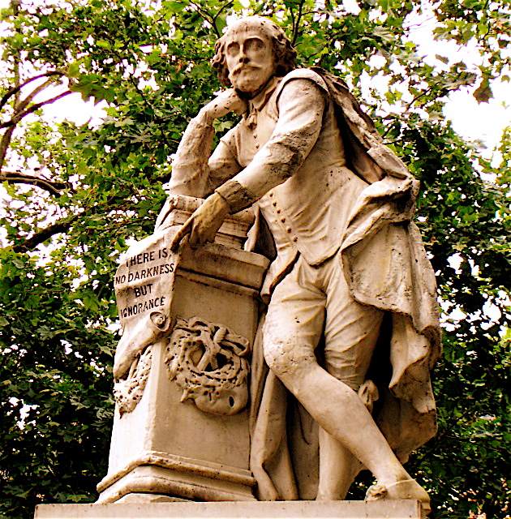

Appendix 3

The tomb of W. Shakespeare in Stratford.

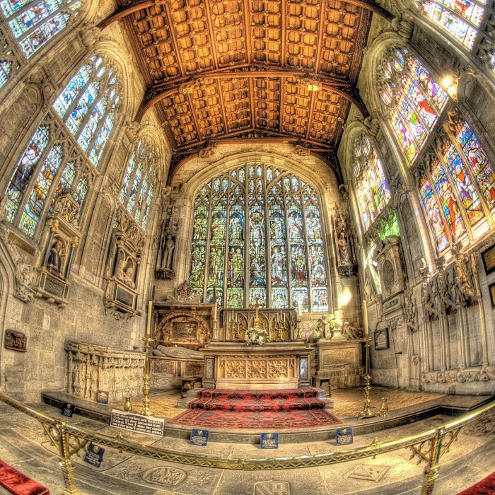

Appendix 4.

Francis Bacon

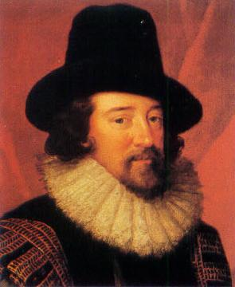

Appendix 5

Delia Bacon

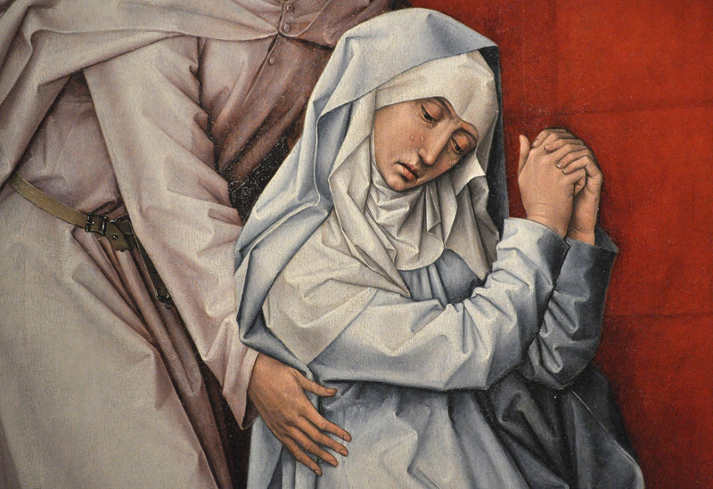

Appendix 6

Christopher Marlowe

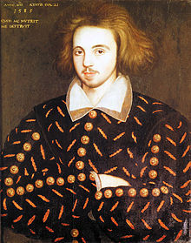

Appendix 7

Edward de Vere

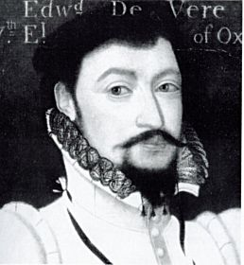

Appendix 8

W. Shakespeare and his characters

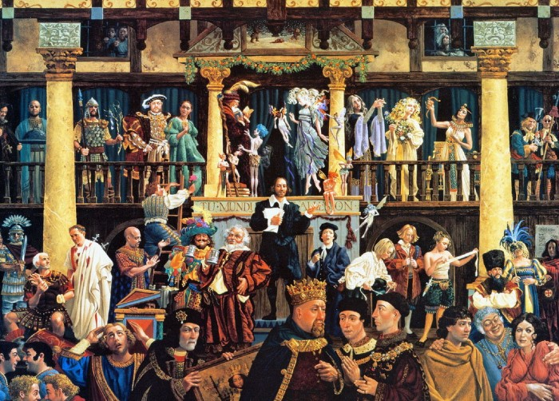

The list of literature

- http://www.litra.ru/biography/get/wrid/00186111189770365693
- http://www.c-cafe.ru/days/bio/6/027.php
- http://www.peoples.ru/art/theatre/dramatist/wiliam_shakespeare/
- http://shaxper.narod.ru/
- http://www.cyberzation.com/index.php/video
- Carrell J.L. Shakespeare Secret

